**R Code for Examples in the book**

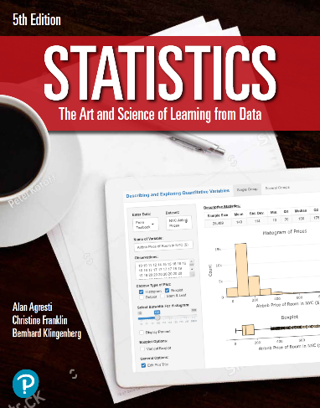

***“Statistics: The Art and Science of Learning from Data”***

**by Agresti, Franklin and Klingenberg, 5th edition**

**Chapter 6**

**Example 3: Expected Number of Games – Mean of a Probability Distribution**

## Reading in the data

games <- c(4, 5, 6, 7)  
probs <- c(0.125, 0.25, 0.3125, 0.3125)

## To compute the mean of this probability distribution, you can use

sum(games * probs)

## [1] 5.8125

## or

weighted.mean(games, probs)

## [1] 5.8125